Notice of Intent [NoI] – (Sample Only)

Company | [Debtor] | From:
Attn | [Debtor Contact] | Carbon Copy [CC]:
Address | [Debtor Address 1], [Debtor Address 2] | Reference: | [Debtor]
 | [Debtor Post Code], [Debtor Country] | Phone (Direct): | [Debtor Telephone]
Dear [Debtor Contact First Name], |  | [Date], [Year]

We intend to sell our invoices payable by your company, [Debtor], to Credebt Exchange®. As you will see below, this is a new and radical service that provides us with an alternative source of working capital that is more cost effective than traditional lending, bank overdrafts, etc. The following provides an overview and information on Credebt Exchange® and also a brief ‘pros & cons’ of supporting us and/or Credebt Exchange®:

Summary |  | Description
Credebt Exchange®  is a gateway to the  capital markets |  | Credebt Exchange® is a gateway to the capital markets. The Exchange enables business invoices to be offered as Exchange Traded Receivables [ETR] for sale on a wholesale basis
Seeking 5-9% and is ready to buy your invoices |  | With no access to the capital markets, your suppliers are paying 9½ - 10¾% p.a. for working capital. Credebt Exchange® are willing to Buy these invoices at 4¾-9½% p.a.
And these are authenticated with you |  | Prior to Credebt Exchange® paying for the invoice, it is authenticated with the you (if you agree to support us)
As the Debtor to your suppliers, you can help |  | As a third-party to the transaction, we would appreciate your input on how to do this, without affecting your payment process
More elegant than alternative solutions |  | Offering supplier finance directly is an option (see ‘Pros & Cons’ below), but supporting Debtors Exchange® is much easier
‘good for your suppliers & good for you’ |  | A financially strong supplier can grow and improve their business and offer your company a more reliable supply chain

As a long standing supplier to your company, we hope that you will support us, and Credebt Exchange®, so that we can access this more cost effective form of working capital.

The remainder of this communication explains how the invoices will be stamped and the simple change in your payments process. If there are any issues with our electing to work with Credebt Exchange®, or any aspect of this communication that you are unclear about, please do to hesitate to contact me, Credebt Exchange®, directly.

Sincerely,

[Originator Contact]
[Originator Title

Information
Ireland Calling…

Throughout the island of Ireland, Small & Medium Enterprise [SMEs] need your support. The Government alone cannot solve the issues facing SMEs. It requires the participation and support of larger corporations such as yours.

Epidemic lack of Working Capital

1 in 5 companies with T/o < €15M
need access to Working Capital

The downturn in the economy affects everyone. Few industry sectors are unaffected by the continuing uncertainty and lack of liquidity (i.e. working capital).

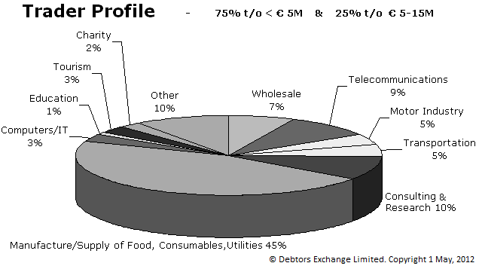

Some are affected more than others but the message is singular:

‘With access to Working Capital we can not only survive, we can grow’

A working solution - Credebt Exchange®

Credebt Exchange® is a specialist financial exchange that enables business invoices to be offered as Exchange Traded Receivables [ETR]. Investors, or buyers, are from the pensions, capital and/or money markets. As a new and alternative source of Working Capital, the key objective is to achieve rates that are less than current commercial lending rates.

Socially Responsible Solution
“The brands that will be big in the future will be those that tap into the social changes that are taking place.” Sir Michael Perry, Chairman, Centrica PLC

Credebt Exchange® is specifically designed to ease the burden on SMEs without placing onerous expectations on larger corporations. Some of your suppliers want to leverage Credebt Exchange® to access working capital more competitively. By supporting the Exchange, you’re supporting them.

What’s Required of You?

Very little - other than a one-time set up of a new ‘Branch Account’ in your Accounts Payable [AP] system. Your supplier will invoice you as usual. The difference being:

- Every invoice sold on the Exchange will carry a stamp (or other notification)
- When the paying the invoice, you pay the AP Branch Account instead



Perhaps you’d like to Participate

If your organisation wants to become an active Investor and purchase trade invoices on the Exchange (from your own suppliers, or others); or should you require further information, use the website or telephone number above, or this email us at:-

debtor@credebtexchange.com

Credebt Exchange®
Overview
Providing Liquidity to Economic Recovery
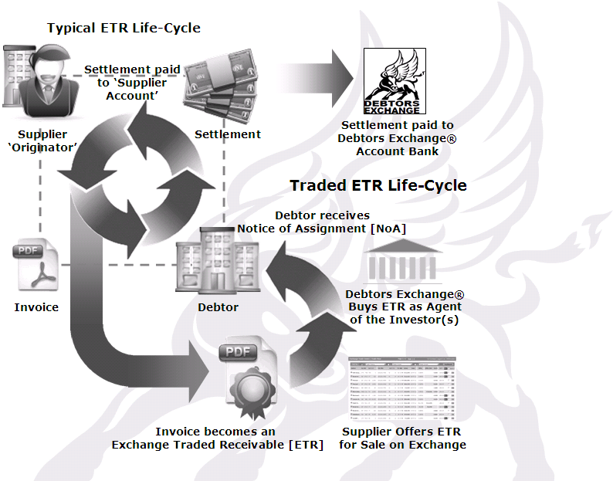

Who Are We?

Credebt Exchange® is a privately owned, wholly Irish, limited liability company. The founders have a combined 80+ years of experience in business, trading, receivables management and the financial markets.

Why are Originators Seeking this Service?

Traditional lending and/or the lack of access to working capital continues to decline. The adverse affect on the ‘liquid lifeblood’ of the economy requires a new solution: Credebt Exchange® alternative working capital.

We would like you to support Credebt Exchange® and, in so doing, support your suppliers too.

Why is Credebt Exchange® the Solution?

As an open marketplace, Credebt Exchange® is an efficient mechanism for providing alternative working capital to your suppliers (i.e. invoice sellers); Investors are seeking modest returns, with low risk; and as the Debtor, your organisation’s pedigree means you can support your suppliers with minimal effort.

How You can Support Your Suppliers

Allow them to actively participate on the Exchange and trade their invoices to you. If you wish, you can also participate as an Investor and/or you could also increase your Accounts Receivables credit terms by 5-10% (for those suppliers you agree to support).
Credebt Exchange® Vs alternative supplier funding/no funding at all
Credebt Exchange® |  |  | Alternative supplier funding
Credebt Exchange® benefits you without disadvantaging your suppliers, where you can be an Investor, or where you support us and add 5-10% to your credit terms |  |  | Offering alternative funding to suppliers is a ‘thorny issue’ and could be perceived, incorrectly, as capitalising on the ‘credit crunch’ rather than facilitating better trading conditions
The Exchange is a marketplace with many Originators (i.e. invoice sellers) and Investors (i.e. invoice buyers). As an Exchange, fair market price is ensured |  |  | An obvious alternative solution is Supply Chain Finance [SCF] (albeit that SCF has experienced low rates of adoption and success), but do you want to set up and manage an SCF network?
Credebt Exchange® is a very transparent marketplace, specifically designed to ensure the lowest cost of capital to the Originators that sell their invoices |  |  | If you offer to discount your suppliers’ invoices in exchange for early payment, you don’t need Credebt Exchange®, but how will you ensure that your suppliers get the lowest cost of capital?
In this open marketplace, Originators drive price advantage without affecting their relationship with their Debtors |  |  | If you offer a discount for early payment against already negotiated prices, how will this affect the delicate relationship with your suppliers?
Although Debtors’ names are visible on the Trade Floor, Investors’ & Originators’ are not. Pricing is transparent only insofar as it relates to the cost of capital |  |  | Whatever method or system you choose to offer your suppliers for a discounted early payment, how will you ensure transparency and display ‘fairness’ in what will be a ‘closed’ environment?
Investors are specifically capitalised to purchase Originators’ invoices in volume on the Exchange |  |  | Committing to fund a SCF system, or getting external funding, is an option, but apart from the sizable commitment, will it be available to all?
 |  |  | No funding at all
If you permit/support the trading of your invoices on the Exchange, you could potentially ‘loose control’ over suppliers’ overall obligations to you. In certain instance and at your discretion, you could prevent specific suppliers from trading |  |  | You could assume the position that your suppliers’ working capital issues are outside your remit and simply reject our request for your support. Although this may seem a reasonable approach, surely supporting the Exchange will resonate well with suppliers using the service?
Finally, as a spot market, it is highly unlikely that a single supplier will trade/sell all your invoices. Therefore, it should not affect their overall service commitments and obligations to you |  |  | By clearly instructing us on your processes and requirements, prior to offering your support for Credebt Exchange®, you can ensure that any trading in your invoices does not affect the overall quality of your suppliers’ goods/services
Conclusion: | Credebt Exchange® is non impactful. It Benefits You & Your Suppliers
Pros & Cons

Appendix III – Notice of Assignment [NoA]
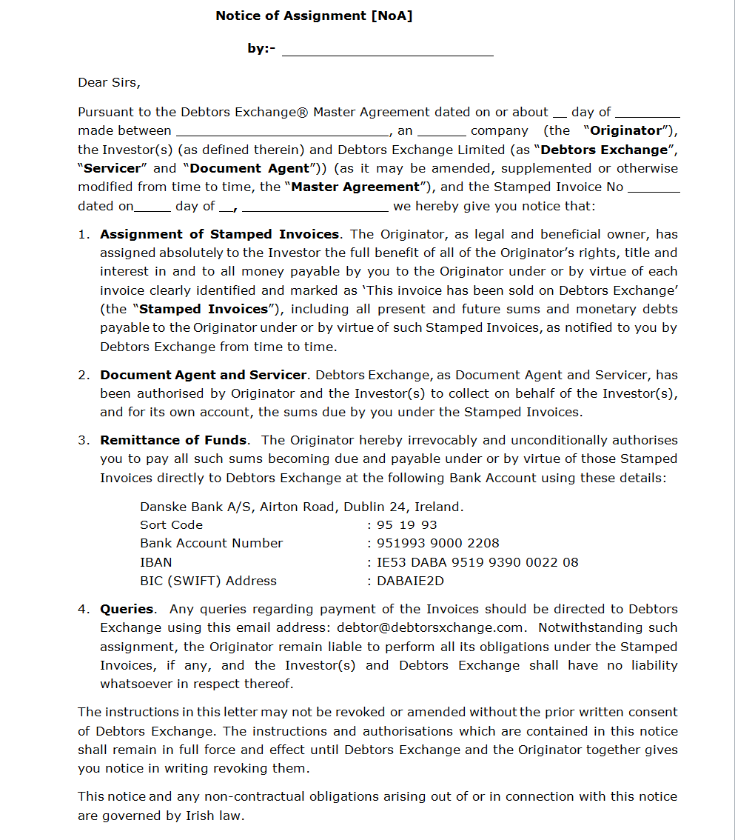
Irish
Type Originator’s Name over this
Type Originator’s Name over this
Enter Month
XX

